**Human-Computer Interaction (HCI)**

**Sheet #1**

1. **What is the definition of HCI?**

(human-computer interaction) is the study of how people interact with computers and to what extent computers are or are not developed for successful interaction with human beings.

1. **What is the basic goal of HCI?**

A basic goal of HCI is to improve the interactions between users and computers by making computers more usable and receptive to the user's needs. A long-term goal of HCI is to design systems that minimize the barrier between the human's cognitive model of what they want to accomplish and the computer's understanding of the user's task.

1. **What are the methods and techniques which HCI is concerned with?**

HCI is concerned with:

1. methodologies and processes for designing interfaces (i.e., given a task and a class of users, design the best possible interface within given constraints, optimizing for the desired property such as learning ability or efficiency of use)
2. methods for implementing interfaces (e.g. software toolkits and libraries; efficient algorithms)
3. techniques for evaluating and comparing interfaces
4. developing new interfaces and interaction techniques
5. developing descriptive and predictive models and theories of interaction
6. **What is the difference between the professional practitioners and the researchers in HCI?**

Professional practitioners in HCI are usually designers concerned with the practical application of design methodologies to real-world problems. Their work often revolves around designing graphical user interfaces and web interfaces. Researchers in HCI are interested in developing new design methodologies, experimenting with new hardware devices, prototyping new software systems, exploring new paradigms for interaction, and developing models and theories of **interaction.**

1. **What is usability? What are the features of the useable system?**

Usability is one of the key concepts in HCI. It is concerned with making systems easy to learn and use.

A usable system is:

* 1. easy to learn
  2. easy to remember how to use
  3. effective to use
  4. efficient to use
  5. safe to use
  6. enjoyable to use

1. **What are the factors which should be considered in the analysis and design of a system using HCI principles?**

The main factors are

* + **Organization Factors:** Training, job design, politics, roles, work organization
  + **Environmental Factors:** Noise, heating, lighting, ventilation, Health and Safety Factors
  + **The User:** Cognitive processes and capabilities, Motivation, enjoyment, satisfaction, personality, experience
  + **Comfort Factors:** Seating, equipment, layout.
  + **User Interface:** Input devices, output devices, dialogue structures, use of color, icons, commands, navigation, graphics, natural language, user support, multimedia,
  + **Task Factors:** Easy, complex, novel, task allocation, monitoring, skills
  + **Constraints** Cost, timescales, budgets, staff, equipment, buildings
  + **System Functionality** Hardware, software, application
  + **Productivity Factors** Increase output, increase quality, decrease costs, decrease errors, increase innovation

1. **What are the main disciplines which have contributed to HCI?**

Some of the main disciplines which have contributed to HCI are

* 1. Computer Science
  2. Cognitive Psychology
  3. Social Psychology
  4. Ergonomics/Human Factors
  5. Linguistics
  6. Artificial Intelligence
  7. Philosophy, Sociology & Anthropology
  8. Engineering & Design

**Sheet 2: The computer**

* **What is the basic architecture of a computer system?**
* The basic architecture of a computer system consists of the computer itself (with associated memory), input and output devices for user interaction and various forms of hard copy devices.
* A typical configuration of user input/output devices would be a screen with a keyboard for typing text and a mouse for pointing and positioning. Depending on circumstance, different pointing devices may be used such as light pen (for more direct interaction) or a trackball (especially on portable computers).
* The computer itself can be considered as composed of some processing element and memory. The memory is itself divided into short term memory which is lost when the machine is turned off and permanent memory which persists.
* How do you think new, fast, high-density memory devices and quick processors have influenced recent developments in HCI? Do they make systems any easier to us? Do they expand the range of applications of computer systems?
* Arguably it is not so much the increase in computer power as the decrease in the cost of that power which has had the most profound effect. Because, ‘ordinary’ users have powerful machines on their desktops it has become possible to view that power as available for the interface rather than hoarded for number crunching applications.
* Modern graphical interaction consumes vast amounts of processing power and would have been completely impossible only a few years ago.
* There is an extent to which systems have to run faster to stay still, in that as screen size, resolution and color range increase, so does the necessary processing power to maintain the ‘same’ interaction. However, this extra processing is not really producing the same effect, screen quality is still a major block on effective interaction.
* The increase in RAM means that larger programs can be written, effectively allowing the programmer ‘elbow room’. This is used in two ways: to allow extra functionality and to support easier interaction.
* Whether the former really improves usability is debatable —unused functionality is a good marketing point, but is of no benefit to the user.
* The ease of use of a system is often determined by a host of small features, such as the appropriate choice of default options. These features make the interface seem ‘simple’, but make the program very complex and large.
* What input and output devices would you use for the following systems? For each, compare and contrast alternatives, and if appropriate indicate why the conventional keyboard, mouse and CRT screen may be less suitable.

a) Portable word processor

b) Tourist information system

c) tractor-mounted crop-spraying controller

d) Air traffic control system

e) Worldwide personal communications system

f) Digital cartographic system

**a) portable word processor**

* The determining factors are size, weight and battery power. However, remember the purpose, this is a word processor not an address book or even data entry device.

LCD screen —low power requirement

Trackball or stylus for pointing

Real keyboard – you can’t word process without a reasonable keyboard and stylus handwriting recognition is not good enough.

Small, low power bubble-jet printer — although not always necessary, this makes the package stand alone. It is probably not so necessary that the printer have large battery capacity as printing can probably wait until a power point is found.

**b) Tourist information system**

* This is likely to be in a public place. Most users will only visit the system once, so the information and mode of interaction must be immediately obvious.

Touch screen only — easy and direct interaction for first time users .

NO mice or styluses—in a public place they wouldn’t stay long!

**c) tractor-mounted crop-spraying controller.**

* A hostile environment with plenty of mud and chemicals. Requires numerical input for flow rates etc., but probably no text.

Touch sensitive keypad —, ordinary keypads would get gunged up.

Small dedicated LED display (LCD often can’t be read in sunlight and large screens are fragile.

Again no mice or styluses—they would get lost.

**d) Air traffic control system**

* The emphasis is on immediately available information and rapid interaction. The controller cannot afford to spend time searching for information, all frequently used information must be readily available.

Several specialized displays — including overlays of electronic information on radar.

Light pen or stylus—high precision direct interaction.

Keyboard —for occasional text input, but consider making it fold out of the way.

**e) worldwide personal communications system**

* Basically a super mobile phone! If is to be kept on hand all the time it must be very light and pocket sized. However, to be a ‘communications’ system one would imagine that it should also act as a personnel address/telephone book etc.

Standard telephone keypad—the most frequent use

Small dedicated LCD display —low power, specialized functions.

Possibly stylus for interaction — it allows relatively rich interaction with the address book software, but little space.

A ‘docking’ facility — the system itself will be too small for a full sized keyboard (!), but you won’t want to enter in *all* your addresses and telephone numbers by stylus!

**f) digital cartographic system**

* This calls for very high precision input and output facilities. It is similar to CAD in terms of the screen facilities and printing, but in addition will require specialized data capture.

Large high resolution color VDU (20 inch or bigger) — these tend to be enormously big (from back to front). LCD screens, although promising far thinner displays in the long term, cannot at present be made large enough.

Digitizing tablet—for tracing data on existing paper maps. It could also double up as a pointing device for some interaction.

Possibly thumbwheels—for detailed pointing and positioning tasks.

Large format printer — indeed VERY large an A2 or A1 plotter at minimum.

**Sheet #3**

* 1. **What are the seven stages of Donald Norman’s model?**
  2. user establishes the goal
  3. formulates intention
  4. specifies actions at interface
  5. executes action
  6. perceives system state
  7. interprets system state
  8. evaluates system state with respect to goal
* The user chooses a goal; formulate a plan of action, which is then executed at the computer interface. When the plan or part of the plan has been executed, the user observes the computer interface to evaluate the result of the execution plan, and to determine further actions.
* The two major parts, execution and evaluation, of interactive cycle are further subdivided into seven stages, where each stage is an activity of the user. Seven stages of action are shown in figure. To understand these we see an example, which was also used by Norman.

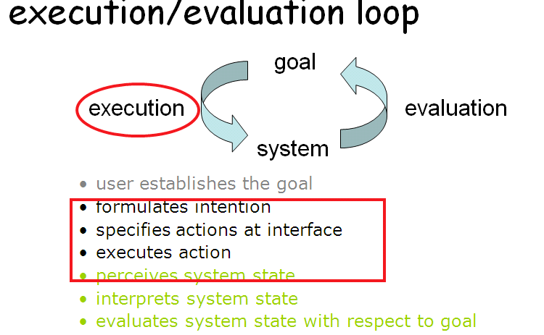

Imagine you are sitting reading as evening falls. You decide you need more light; that is you establish the goal to get lighter. From there you form an intention to switch on the desk lamp, and you specify the actions required to reach over and press the lamp switch. If someone else is closer, the intention may be different-you may ask them to switch on the light for you. Your goal is the same but the intention and actions are different. When you have executed the action you perceive the result, either the light is on or it isn’t and you interpret this, based on your knowledge of the world. For example, if the light does not come on you may interpret this as indicating he bulb has blown or the lamp is not plugged into the mains, you will formulate the new state according to the original goals – is there is now enough light? It so, the cycle is completed. It not, you may formulate a new intention to switch on the main ceiling light as well.

1. **What is the difference between slips and mistakes?**

Slips:

* understand system and goal
* correct formulation of action
* incorrect action

Mistake

* + may not even have right goal!

Fixing things?

* + Slip – better interface design
  + Mistake – better understanding of system

1. **Define Ergonomics and clarify your definition by examples?**
2. Study of the physical characteristics of interaction
3. Examples:
   1. arrangement of controls and displays: e.g. controls grouped according to function or frequency of use, or sequentially
   2. use of color: e.g. use of red for warning, green for okay, awareness of color-blindness etc.
4. **What are the Common interaction styles?**

* command line interface
* menus
* natural language
* question/answer and query dialogue
* form-fills and spreadsheets
* WIMP (windows, icons, menus, and pointers)
  + Windows: scrollbars
* point and click

1. **Choose two of the interaction that you have experience of using. Use the interaction framework to analyze the interaction involved in using these interface styles for a database selection task. Which of the distances is greatest in each case?**

* For this example we will choose a common database selection task — that of selecting records from an online library database. The two interaction styles we will analyze are a natural language interface and a command line interface.
* The task is to select a set of references from the library database that satisfy some search criteria. Once the task has been formulated in the user’s task language (for instance, the user wants to see all of the books written by Alan Dix since 1990), that task must be articulated in the input language.
* A natural language interaction style would allow the user simply to type in the selection query exactly as they think of it. The articulation distance is small because it is both easy to articulate (possibly even easier if a spoken interface is provided rather than typing) and the coverage is total (the user is allowed to articulate anything as a query).
* On the other hand, for a command line interface, the limited vocabulary of the input language makes it more difficult for the user to articulate a task even though the limited language provides complete coverage in terms of possible queries allowed. The real difficulty for a natural language interface is how the system translates the input expression into the actual query that accesses the library records. This performance translation would be much easier for the command line interface since it may not even require any translation of an input expression, that language having already been constructed with the database engine in mind. Therefore, we can see that for a natural language interface, the performance distance is greatest, whereas for a command line interface it is the articulation distance which is greatest. But the above analysis only really deals with the execution translations.
* On the evaluation side, a natural language interface must try to present the results of the database query in the form in which the user phrased the question. This could in general be a difficult translation for the system as it attempts to answer questions in the style in which an arbitrary user has posed that question. Having accomplished that, the observation by the user should be easy to perform. For a command line interface, there is no guarantee that the result of the query will be automatically displayed and the user may have to explicitly request a display (and they may have to express how the display be formatted). Neglecting that point, presentation by the system is made easier as the output language can be very constrained. Observation is made more difficult as the user must translate the output into the terms of their original task formulation. For example, having asked for books by Alan Dix published after 1990, the user may have a difficult time locating author name and year of publication to determine if the resulting records match their expectations. For evaluation, a natural language interface has a greater presentation distance and a command line interface a greater observation distance. In general, therefore, we would expect that a natural language interface would be easier from the user’s perspective but more difficult from the system builder’s perspective. The opposite should hold for a command language interface.
* The interaction framework: The interaction framework breaks the system into four main components as shown in figure. The nodes represent the four major components in an interactive system – the System, the User, the Input and the Output. Each component has its own language. The system and user are each described by means of a language that can express  concepts  relevant in the domain of the application. The system’s language is referred as the core language and the user’s language is referred as the task language. The core language describes computational attributes of the domain relevant to the system state, whereas the task language describes psychological attributes of the domain relevant to the user state. There are also languages for both the input and output components. Input and output together form the interface. As the interface sits between the user and the system, there are four steps in the interactive cycle, each corresponding to a translation from one component to another, as shown by the labeled arcs in figure. The user begins the interactive cycle with the formulation of a goal and a task to achieve that goal.
* The only way the user can manipulate the machine is through the input, and so the task must be articulated within the input language, the input language is translated into the core language as operations to be performed by the system. The system then transforms itself as described by the operations; the execution phase of the cycle is complete and the evaluation phase now begins. The system is in a new state, which must now be communicated to the user. The current values of system attributes are rendered as concepts or features of the output. It is then up to the user to observe the output and assess the results of the interaction relative to the original goal, ending the evaluation phase and, hence, the interactive cycle.
* There are four main translations involved in the interaction: articulation, performance, presentation and observation.



* The user’s formulation of the desired task to achieve some goal needs to be articulated in the input language. The tasks are responses of the user and they need to be translated to stimuli for the input. As pointed out above, this articulation is judged in terms of the coverage from tasks to input and the relative ease with which the translation can be accomplished.
* The task is phrased in terms of certain psychological attributes that highlight the important features of the domain for the user. If these psychological attributes map clearly onto the input language, then articulation of the task will be made much simpler.
* Evaluation phase now begins. The system is in a new state, which must now be communicated to the user. The current values of system attributes are rendered as concepts or features of the output. It is then up to the user to observe the output and assess the results of the interaction relative to the original goal, ending the evaluation phase and, hence, the interactive cycle.

**Sheet# 4: Data Gathering**

* + - 1. **What are the four key issues of data gathering?**

1. Setting goals: Decide how to analyze data once collected
2. Relationship with participants
   1. Clear and professional
   2. Informed consent when appropriate
3. Triangulation: Use more than one approach
4. Pilot studies: Small trial of main study
   * + 1. **What are the different data gathering techniques?**

* Data recording: Notes, audio, video, photographs

1. Interviews:
   * Unstructured - are not directed by a script. Rich but not replicable.
   * Structured - are tightly scripted, often like a questionnaire. Replicable but may lack richness.
   * Semi-structured - guided by a script but interesting issues can be explored in more depth. Can provide a good balance between richness and explicability.
2. Questionnaires: Questions can be closed or open
3. Observation
   * Direct observation in the field
     + Structuring frameworks
     + Degree of participation (insider or outsider)
     + Ethnography
   * Direct observation in controlled environments
   * Indirect observation: tracking users’ activities
     + Diaries
     + Interaction logging
       1. **What are the main parts of the interview?**
   1. *Introduction* *–* introduce yourself, explain the goals of the interview, reassure about the ethical issues, ask to record, present any informed consent form.
   2. *Warm-up* *–* make first questions easy and non-threatening.
   3. *Main body –* present questions in alogicalorder
   4. *A cool-off period –* includea few easy questions to defuse tension at the end
   5. *Closure –* thank interviewee, signal the end, e.g., switch recorder off.
      * 1. **What are the Advantages of online questionnaires?**
4. Responses are usually received quickly
5. No copying and postage costs
6. Data can be collected in database for analysis
7. Time required for data analysis is reduced
8. Errors can be corrected easily
   * + 1. **What are the Problems with online questionnaires?**
9. Sampling is problematic if population size is unknown
10. Preventing individuals from responding more than once
11. Individuals have also been known to change questions in email questionnaires

**6. Describe the Structuring frameworks used to guide observation?**

- *The person*. Who?

- *The place.* Where?

- *The thing.* What?

**7. What does Ethnography mean?**

* Ethnography is a philosophy with a set of techniques that include participant observation and interviews

**Sheet#5: Identifying Needs and Establishing Requirements**

**1. What are the main kinds of requirements?**

1. Functional:
   * What the system should do
   * Historically the main focus of requirements activities
2. Non-functional:
   * memory size, response time, security, .....
3. Data:
   * What kinds of data need to be stored?
   * How will they be stored (e.g. database)?
4. **Mention the main methods used in task description?**
5. Scenarios: an informal narrative story, simple, ‘natural’, personal, not generalizable
6. Use cases
   * assume interaction with a system
   * assume detailed understanding of the interaction
7. Essential use cases
   * abstract away from the details
   * does not have the same assumptions as use cases
8. **Hierarchical Task Analysis:**

Example 1:

0. In order to borrow a book from the library

1. go to the library

2. find the required book

2.1 access library catalogue

2.2 access the search screen

2.3 enter search criteria

2.4 identify required book

2.5 note location

3. go to correct shelf and retrieve book

4. take book to checkout counter

plan 0: do 1-3-4. If book isn’t on the shelf expected, do 2-3-4.

plan 2: do 2.1-2.4-2.5. If book not identified do 2.2-2.3-2.4.

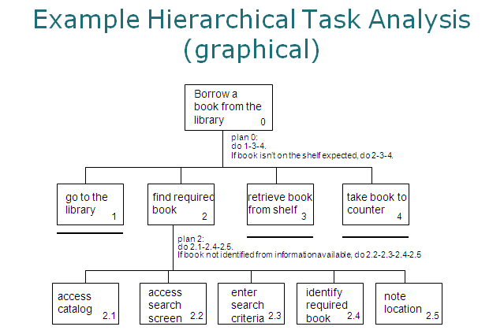

1. **Hierarchical Task Analysis example 2:**

Analyze the following task using the Hierarchical Task Analysis method (by writing the textual notation and drawing the tree).

Task: writing a letter and preparing it for posting.

1. : Write letter and prepare for posting
2. 1: Prepare for writing
3. 1.1: Get paper
4. 1.2: Get envelope
5. 1.3: Get pen
6. 1.4: Get address book (not explicitly stated, but clearly necessary)
7. 2: Write letter
8. 2.1: Write own address
9. 2.2: Write addressee's address
10. 2.3: Write date and "Dear..."
11. 2.4: Write body text of letter
12. 2.5: Sign off
13. 3: Prepare envelope
14. 3.1: Write name on envelope
15. 3.2: Write address on envelope
16. 4: Put letter in envelope
17. 4.1: Fold letter
18. 4.2: Place letter into envelope
19. 4.3: Seal envelope

Again, we need plans to describe how to perform each subtask:

1. Plan 1: Do 1.1, 1.2, 1.3 and 1.4 in any order
2. Plan 2: Do 2.1 then 2.2 then 2.3 then 2.4 then 2.5
3. Plan 3: Do 3.1 then 3.2
4. Plan 4: Do 4.1 then 4.2 then 4.3.

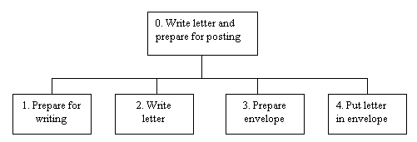

**Sheet 6: Design, prototyping, and construction**

* + - 1. **What is a prototype?**

In interaction design it can be (among other things):

* + a series of screen sketches
  + a storyboard, i.e. a cartoon-like series of scenes
  + a PowerPoint slide show
  + a video simulating the use of a system
  + a lump of wood (e.g. Palm Pilot)
  + a cardboard mock-up
  + a piece of software with limited functionality written in the target language or in another language
    - 1. **Why prototype?**
* Evaluation and feedback are central to interaction design
* Stakeholders can see, hold, interact with a prototype more easily than a document or a drawing
* Team members can communicate effectively
* You can test out ideas for yourself
* It encourages reflection: very important aspect of design
* Prototypes answer questions, and support designers in choosing between alternatives
  + - 1. **What are the two main kinds of prototyping?**

1. Low-fidelity Prototyping

* Uses a medium which is unlike the final medium, e.g. paper, cardboard
* Is quick, cheap and easily changed
* Examples:

sketches of screens, task sequences, etc  
 ‘Post-it’ notes  
 storyboards  
 ‘Wizard-of-Oz’

1. High-fidelity prototyping
   * Uses materials that you would expect to be in the final product.
   * Prototype looks more like the final system than a low-fidelity version.
   * For a high-fidelity software prototype common environments include Macromedia Director, Visual Basic, and Smalltalk.
   * Danger that users think they have a full system
     + 1. **What are the common types of Compromises in prototyping?**

* Two common types of compromise
  + - ‘horizontal’: provide a wide range of functions, but with little detail
    - ‘vertical’: provide a lot of detail for only a few functions
* Compromises in prototypes mustn’t be ignored. Product needs engineering
  + - 1. **What is ment by construction?**
* Taking the prototypes (or learning from them) and creating a whole product.
* Quality must be attended to: usability (of course), reliability, robustness, maintainability, integrity, portability, efficiency, etc
* Product must be engineered

Evolutionary prototyping

‘Throw-away’ prototyping